John Michael Go
Career Entry Level Java Programming
Date: Jan. 17, 2013

DAY 5

Program Name: Gregorian Calendar

Objective: Gregorian Calendar example

Algorithm:

- Program outputs Gregorian Calendar format.

Flowchart:
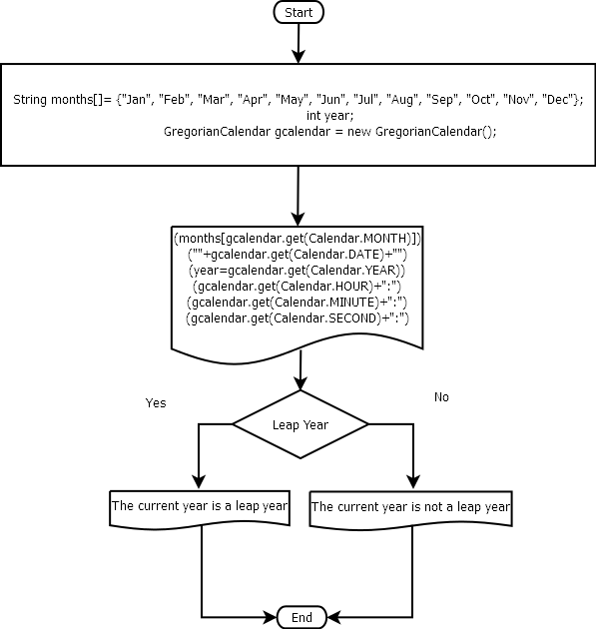

Pseudocode:

/* Program Name: Gregorian Calendar Demo
Created By: John Michael Go
Creation Date: Jan. 17, 2013 Day 5
Note: Gregorian Calendar example
*/

import java.util.*;

public class GregorianCalendarDemo{

public static void main(String[]args){

String months[]= {"Jan", "Feb", "Mar", "Apr", "May", "Jun", "Jul", "Aug", "Sep", "Oct", "Nov", "Dec"};
int year;
GregorianCalendar gcalendar = new GregorianCalendar();
System.out.println("Date");
System.out.print(months[gcalendar.get(Calendar.MONTH)]);
System.out.print(""+gcalendar.get(Calendar.DATE)+"");
System.out.println(year=gcalendar.get(Calendar.YEAR));
System.out.println("Time:");
System.out.print(gcalendar.get(Calendar.HOUR)+":");
System.out.print(gcalendar.get(Calendar.MINUTE)+":");
System.out.print(gcalendar.get(Calendar.SECOND)+":");
if(gcalendar.isLeapYear(year)){
System.out.println("The current year is a leap year");
}else{
System.out.println("The current year is not a leap year");
}

}

}

Screenshots:

